#### Bakground information

***Better Off Ted*** was an American satirical situation comedy series which ran on the ABC network from March 18, 2009 to January 26, 2010.

#### Main characters:

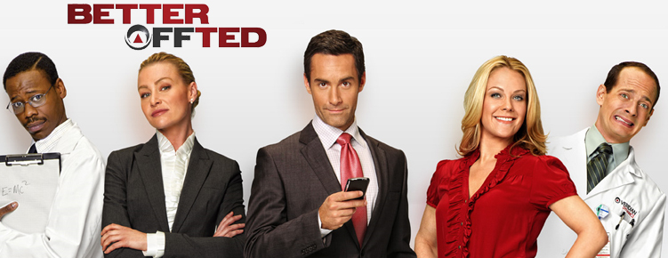

|  |  |  |  |  |
| --- | --- | --- | --- | --- |
| **Lem** | **Veronica** | **Ted** | **Linda** | **Phil** |
| A laboratory  scientist | Ted's boss and immediate supervisor at Veridian Dynamics | The show's narrator who often addresses himself directly to the viewers | A tester in one of Veridian's departments | A laboratory  scientist |

## Better Off Ted (Season One, Episode 2) The Meat Blob

### (00:00-00:040) Ad for Veridian Dynamics:

**Fill in with the missing words**

“Veridian Dynamics. We’re the ……………………………. of food. Developing the ……………………………. generation of food and ……………………………………….. products. Tomatoes: the …………………………. of this baby. Lemon-……………………………. fish. Chickens that lay sixteen eggs …………………………….. (2 words), which is a lot for a chicken. ………………………………….. vegetables, chock-full of ………………………………………………. At Veridian Dynamics we can even make radishes so …………………………………. that people can’t …………………………… them. But we’re not because people can’t ……………………………. them. Veridian Dynamics. Food. Yum.”

### (00:41-01:35) Small talk

What is Ted’s job?

What does his job entail?

What is the company’s problem?

|  |  |  |  |
| --- | --- | --- | --- |
| **Company division directly concerned by the problem** | **Faulty product** | **People the product will be presented to** | **2 problems it causes** |
|  |  |  | …  … |

What does Veronica want for the following week?

### (01:54-04:05) The meeting

What expression does Ted use to refer to the projects which are being developed? Fill in missing words:

“So we looked at what we have …………………………………………………… (three words)”

Fill in the following with the missing words to describe Phil and Lem’s project:

* Beef ……………………………………. cows
* Bovine ………………… surrounded in a bed of rich ………………………….. grown in a fully developed cow …………………………….
* ……………………………………. meat grown in a …………………………………..

What strange behavior does Phil have in the middle of the meeting?

What are the three “possible” explanations put forward by the company’s legal department and by Ted himself?

* …
* …
* …

How does Veronica get Phil to stop?

When Linda finally arrives to the meeting, how does she describe Phil and Lem’s project?

What is the deadline imposed by Veronica to carry out the project?

**True or False:** meat grown in a test tube does not have any feelings.

### (04:06-04:40)In the lab

What are Lem and Phil doing?

What nickname does Phil propose?

Finish Lem’s sentence: “Don’t name it or …………………………………………………………………………………..”

What precedent was there for this theory?

### (06:50-07:20)The best team

What examples of Lem and Phil’s feats does Ted offer?

* …
* …
* …

### (10:20-11:44) The taster

**Spot and correct the mistakes:**

**Veronica:** Jerome. Isn’t he still in the cafeteria from the “Extra Fun Mac & Cheese”?

**Ted:** No. He got his eye sight front. He just had to scrape some of the “Extra Fun” mac & cheese.

**Veronica:** *(in the lounge)* What the hell keeps happening with the creamer?

**Ted:** You have to stop stealing creamer.

**Linda:** No. Is Blobby inside?

**Ted:** Yes. And we’re not calling him Blobby. You know, because of Chester, the core. *(Inside the tasting room)*They’re going to catch you.

**Linda:** That’s a chance I’m ready to take.

**Ted:** Hi Jerome. How are you feeling?

**Jerome:** Better thanks, but I still can’t see red. What do we have today?

**Ted:** You tell us. *(To Linda)* If they caught you, they’re going to fire you. And if they fire you, well, you wouldn’t be here anymore.

**Linda:** I know, but if I had stopped, I feel like I’ll be giving up a piece of my soul. beside when this company eliminates cows, those creamers are going to be worth a fortune.

**Jerome:** It tastes familiar.

**Ted:** Beef?

**Jerome:** No.

**Linda:** Chicken? We’ll take chicken.

**Ted:** What does it taste like?

**Jerome:** despair?

**Ted:** Is it possible that it just needs salt?

### (17:25-19:40) Heroes

What do Phil and Lem realize their problem with the blob was?

What conclusion do they come to?

List/describe the three approaches experimented? Which ones are rejected? Which one seems successful?

* …
* …
* …

What is Ted’s definition of a hero?

“Maybe it’s just someone who ………………………………………… (two words) when others need him to”

What is the final revelation concerning this blob?